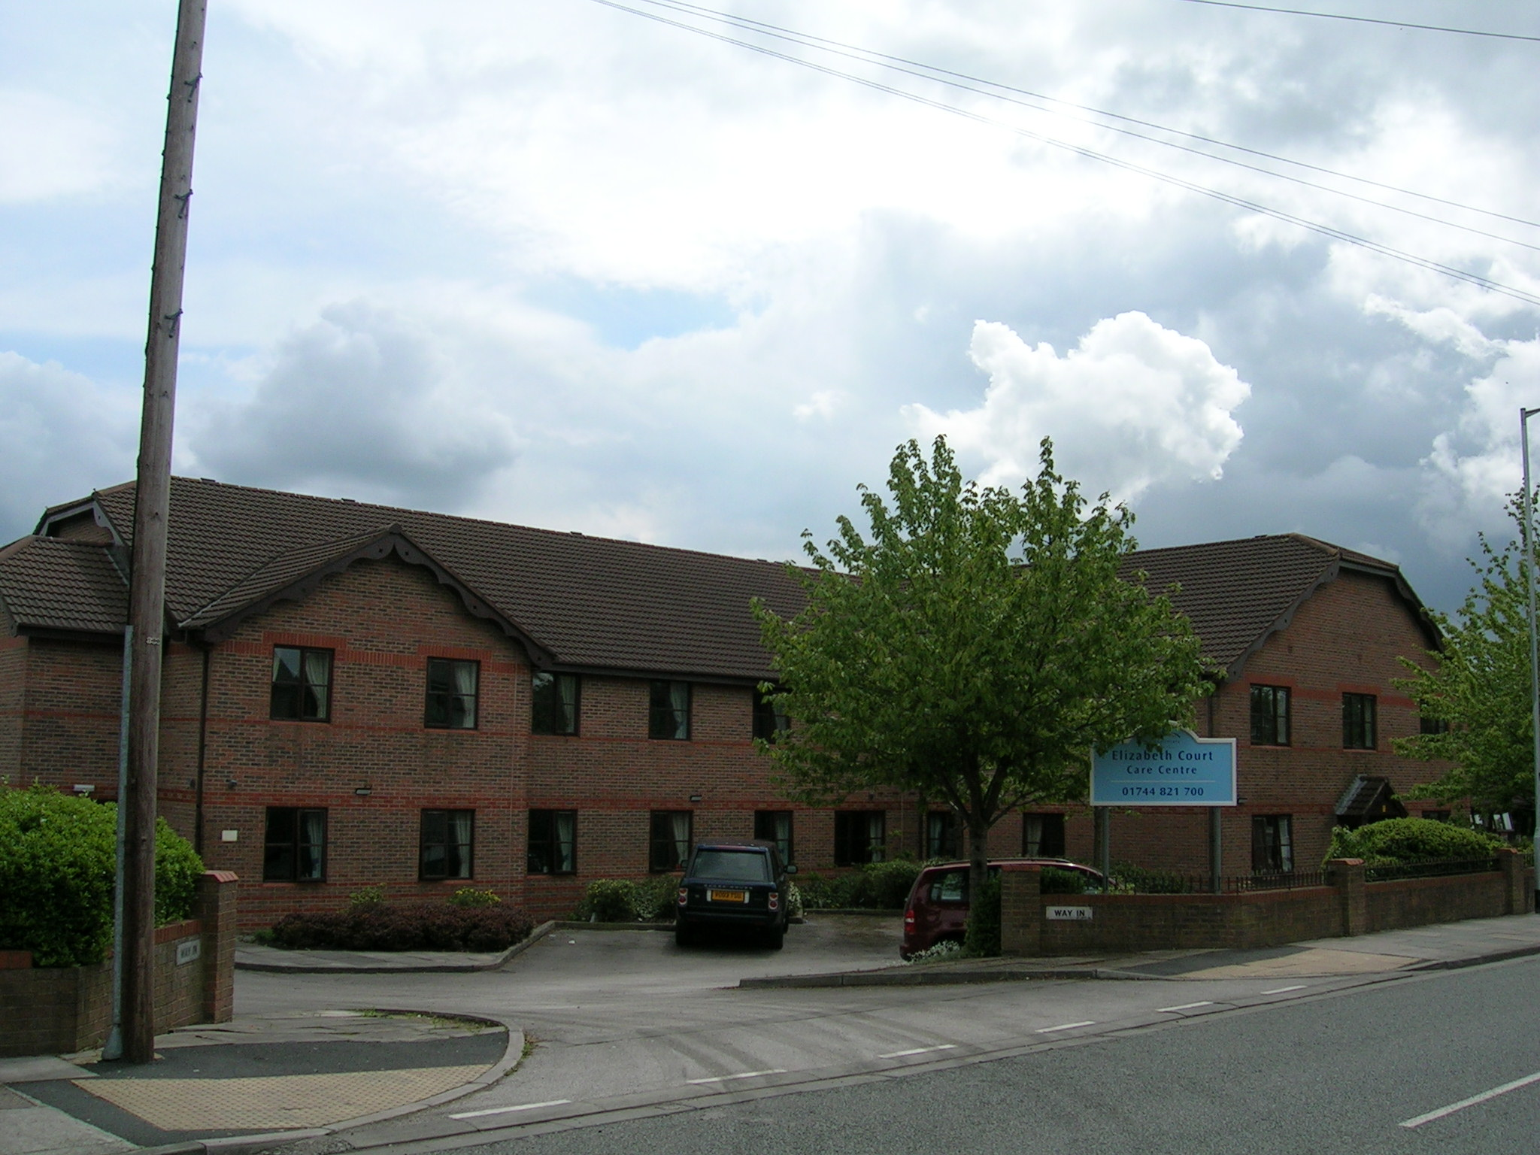 

**Elizabeth Court Care Centre**

**At Elizabeth Court Care Centre** we aim to look after not just your health but your whole wellbeing. We arrange regular visits from hairstylists and other professionals such as opticians when needed and you are welcome to keep your own doctor or dentist where convenient.

Elizabeth Court Care Centre is a modern and specially designed two-storey Care Centre situated in a quiet residential area in Sutton, St Helens. The Centre offers a homely, yet secure environment with its own private grounds.

On your first arrival at Elizabeth Court Care Centre a dedicated named nurse or carer will be given prime responsibility for helping you to settle in and will draw up a personalised care plan setting out any treatments and services. This will be regularly reviewed to reflect your needs.

It is important to us that you feel at home so you are welcome to bring personal belongings for your room, photographs, ornaments or pieces of furniture space permitting and that they meet Health & Safety regulations.

Family and friends are always welcome to visit you at anytime, and if you let us know they are coming, we can arrange for them to have meals with you.

We offer tastefully decorated spacious single en-suite bedrooms, each with a call system for contacting staff if you need help.

When you feel like socialising, we have four spacious lounges to relax in, each with a TV. Our lawns and patio are ideal for taking in the sun or enjoying a visit with your family and friends.

We regularly plan social activities for you to enjoy, including in-house entertainments and special celebrations at Christmas, Easter and Halloween. We also arrange day trips and outings to local attractions and beyond. Of course it is up to you how much you get involved. You may prefer to read quietly in your room or pursue your own hobby and we fully respect your privacy.

Your religious beliefs are also important to us. You can visit your local place of worship where possible and if you wish, we will be delighted to arrange for your local Minister to visit you.

For residents with special physical needs, we have wheelchair access to all indoor and outdoor areas, bath lifts and specially designed shower rooms.

If you have a special diet for medical, religious or cultural reasons, our chefs will happily cater for your needs, providing appetising, home-cooked dishes that can be eaten in your bedroom. We can also serve drinks and snacks whenever you feel like refreshments.

At every Key Healthcare Centre, our priority is to provide you with excellent 24-hour care. Our Senior Directors carry out regular checks in all our Care Centres to make sure that we meet the highest levels of care possible, as set out by the National Care Standards.

Led by the Home Manager, our professional team includes qualified nurses who are on duty around the clock including, carers, chefs, housekeepers and maintenance staff. Through our on-going training programme, all staff are encouraged to develop their professional skills to keep them up-to-date in the care and support they give.

Elizabeth Court Care Centre provides nursing and residential care for older people who suffer from dementia, mental health needs and functional disorders. We are regulated by the Commission for Social Care Inspectorate.

We offer:

* 24 bed nursing unit
* 19 bed residential unit
* All 43 beds have en-suite facilities
* 4 spacious day lounges
* 2 dining rooms
* Lawned gardens and secure patio area
* Lift and wide corridors for wheelchair access
* Registered nurses and staff trained in dementia care
* Full activities programme

For further information and to arrange a viewing please contact:-

The Manager

Elizabeth Court Care Centre

125 New Street

Sutton

St Helens

WA9 3XE

<Tel:-> 01744 821700

Email:- manager.ec@keyhealthcare.co.uk